Homework Problems for Monday January 16, 2017

- Read chapter 1 in Barron, interesting history and background for cryogenics.
- A stainless steel rod with a circular cross section of 15 mm diameter and a length of 3 meters connects room temperature (300 K) to a 5 K heat sink. Considering only conduction, what is the heat leak from 300 K to 5 K? What would be the heat leak if the rod were made of copper?
Stainless thermal conductivity integral 300 – 5 K is 3000 W/m. A/L = 0.0000589, Q= 0.17 W.
Note: for titanium, the thermal conductivity integral from 300 K to 15 K is 1650 W/m. A/L = 0.0000589, Q (to 15 K) = 0.097 W
Copper thermal conductivity integral (OFHC) 300 – 5 K is 150000 W/m. A/L = 0.0000589, Q = 8.8 W

- List 2 effects of the significant decrease of specific heat of metals at cryogenic temperatures
Most heat is removed before we reach 20 K
Cool-down proceeds more quickly as we approach 5 K.
Small heat added at low temperature results in a large temperature rise
Most heat in a liquid helium system may be contained in the helium, not in the metal.

- Calculate the Coefficient of Performance for an ideal Carnot Cycle Refrigerator operating between 300 K and 30 K. How many Watts of power at 300 K are required to remove 1 Watt of heat at 30 K using this refrigerator?

30/(300-30) = 0.111, 9 Watts/Watt

- Wet engine. An expander for which the exhaust contains some (or 100%) liquid is called a “wet” engine. This can be a problem for a turbo-expander but can be an efficiency improvement over a J-T valve for the final expansion in a liquefier. A reciprocating wet expander was part of every Fermilab satellite refrigerator.
For a helium expander with the following conditions:
18 bar inlet pressure
2.0 bar exit pressure
Efficiency = 70%
At approximately what inlet temperature would the exhaust become 2-phase?

Answer:
2 bar exhaust saturated vapor, approx. T = 5.025 K. h= 27.5 J/g. s = 6.952 J/gK.
h(18 bar, s=6.952) = 50.2 J/g (about 10.7 K)
delta-h ideal = 50.2 – 27.5 = 22.7 J/g.
Assume 70% efficiency implies real delta-h = 0.70 x 22.7 = 15.9 J/g
Real delta-h inlet = 27.5 + 15.9 = 43.4 J/g
Real T in = T(18 bar, 43.4 J/g) = 9.75 K

For helium expanded isenthalpically with the following conditions:
18 bar inlet pressure
2.0 bar exit pressure
At approximately what inlet temperature would the exhaust become 2-phase?
Isenthalpic expansion implies T into JT valve is T(18 bar, h = 27.5 J/g) = 6.9 K

Note how much better even 70% efficient expansion is in cooling the helium.

You may use http://webbook.nist.gov/chemistry/fluid/ for helium properties.

- Identify the indicated components on the Collins cycle refrigeration plant schematic shown below:
A

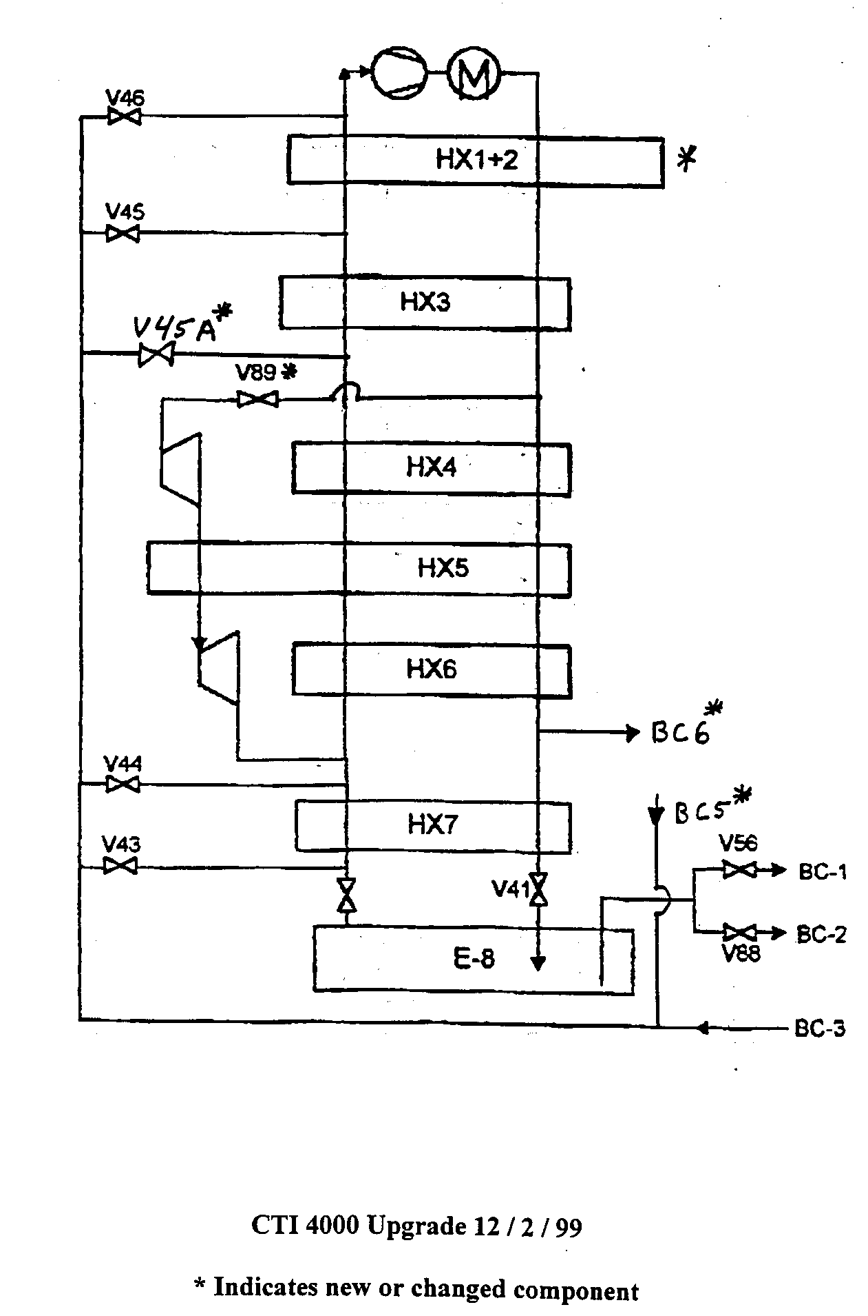
C
A:

B:

C:

D:

E:
E
D
B

A = compressor
B = heat exchanger
C = expander
D = JT valve
E = phase separator

Homework Problems for Tuesday January 17, 2017

- Consider 2 parallel plates each 2 m² in area. They are separated by 0.1 m. Their emissivity is 0.08 One plate is at 300 K and one is at 4.2 K. What is the heat leak due to radiation between the 2 plates? (assume the infinite plate approximation and assume that emissivity = 0.08 is << 1 ).
Q = σ A (e/2) (T1^4-T2^4) = 5.67e-8 (0.08/2) 2 (300^4) = 36.7 W

- For the plates in question above; name 3 ways in which the radiation heat load to 4.2 K may be reduced.
Radiation heat load may be reduced by: reflective surfaces, MLI, intermediate thermal shield.

- In cryostat design, what techniques do we use to reduce the conduction heat leak between room temperature and cryogenic temperatures?
In cryostat design, conduction heat leak is reduced by: low conductivity supports (thin or low conductivity material), thermal intercepts.

- Describe the differences between a Type I and Type II superconductor. Why are Type II superconductors generally more useful for practical applications ?
From John’s slides:
- “Some superconductors have 2 critical fields: below the first (Hc1) all magnetic flux is expelled from the material. Above the first but below the second (Hc2) the flux penetrates in the form of quantized magnetic fields or fluxons. In this “mixed state” the bulk of the material remains superconducting. Such material are called Type II superconductors.”
- “Type II superconductors have much (orders of magnitude) higher upper critical fields and thus are more useful in technology”

- Suppose a short (30 cryomodules) ILC-like pulsed electron linac will operate with 2 K dynamic heat loads like those predicted for ILC but with gaseous helium cooling of the “40 – 80 K” thermal shield really at 40 – 60 K. (You may scale thermal radiation expected based on S1-Global 80 K measurements.) Describe whether you would recommend a 5 Kelvin thermal radiation shield between the 40 – 60 Kelvin thermal radiation shield and 2 K cold mass, or not recommend the 5 Kelvin thermal shield. Explain the reasons for your answer.
Removal of the 5 K thermal shield sends the radiative heat otherwise absorbed at 5 K on down to 2 K.
Total heat load at 2 K would go from 11.4 W / CM (slide 35 in Tom’s cryomodule presentation) to 11.4 + 1.41 (from slide 36) = 12.8 W per CM.

Loss of heat to 4.5 K is same, 14.5 – 1.41 W = 13.1 W.

Difference in refrigeration for the system of 30 CM is 1.41 W x 30 CM = 42 W added to 2.0 K and no longer at 4.5 K.
42 W additional at 2.0 K is about 800 W/W x 42 = 33.6 kW of room T power.
Reduction at 4.5 K is about 250 W/W x 42 W = 10.5 kW. Net increase is about 23.1 kW.

Total refrigeration power needed is approximately (800 x 11.4 + 250 x 14.9 + 16 x 153.5) x 30 = 460 kW.
So 23.1 kW/ 460 kW = 5% effect on total power.

Say $0.10/kW-hr. Cost of 23.1 kW is $0.10 x 24 x 365 x 23.1 = $20K/yr. I would suggest not including the 5 K thermal shield, since I would prefer to simplify the cryostat.

However: arguments for retention include the 5 K shield as “backup” due to inevitable holes through the 40-60 K shield (instrumentation wires, RF power coupler ports, etc.), “insurance” for underperformance of the 40 K shield such as due to warm spots, and reduction of power for a very large, long linac

Homework Problems for Wednesday January 18, 2017

- 2 kW/m² pass through a heated wall. The surface of the wall is covered with He II at 1.8 K Assuming only Kapitza Conductance, what is surface temperature of the wall ? ( take alpha = 0.045 and m = 3)
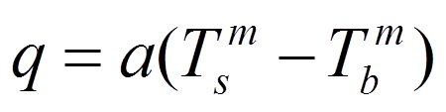
Tb = 1.8 K
a = 0.045
q = 2 kW/m2
Solving for Ts
Ts (wall temperature) = 3.69 K

- Consider a cylindrical tube of He II at 1 atm. The tube is 12 cm long and is 0.25 cm in diameter. One end of the tube is attached to an infinite heat sink kept at a temperature of 1.8 K. The other end of the tube is held at 2 K. Assuming Mutual Friction Heat transfer, how much heat is transferred through the tube? How much heat would be transferred between these temperatures in a pice of copper with the same length and diameter. Assume the thermal conductivity of the copper is constant and equals 20 W/mK
For SF transport, Q = A(f^-1(P,T) dT/dx)^1/3
F^-1(P,T) = 12000 (approximation from figure on John’s slide 14, Helium II talk)
A = (0.0025m)^2 / 4) * Pi = 4.9E-6 m
DT/dx = 0.2 K / 0.12 m
Q = (4.9E-6)x(12000x0.2/12)^1/3 = 0.133 W.

For Copper we have kAdT/dx = 20 W/mK x 0.049 cm2 x (0.2K/12cm) x (1 m/100 cm) = 0.000163 W

- List 3 rules of thumb or best practices to consider when designing cryogenic instrumentation systems
See John’s slide 5 in instrumentation talk.
  - Don’t use more accuracy & precision than required
  - Use commercially produced sensors whenever possible – there is a lot available
  - When possible, mount sensors outside cryostat at 300 K (e.g. pressure transducers, flow meters)
  - For critical devices inside of cryostats, install redundant sensors whenever feasible
  - Be sure to consider how to recalibrate sensors
  - If at all possible avoid, cold instrumentation feed throughs
  - Once R&D is done, minimize number of sensors in series production of cryostats

- Is a Platinum Resistor appropriate for measuring the temperature of a He II Bath? Why?
No. Sensitivity goes away below about 30 K.

- Consider a 1 meter long tube that is 5 mm ID connecting a 4.2 K bath and a 300 K sensor. The tube is sealed at the 300 K end. Assume that the midpoint between the 4.2 K temperature and the 300 K temperature occurs at the 0.5 meter point on the tube wall. Are thermoacoustic oscillations likely to occur in this tube?
Xsi = 1. 5 mm ID and 1 m long. See John’s Instrumentation talk slide 22. Alpha = Th/Tc = 60. It looks unstable.

- What two aspects make Oxygen Deficiency Hazards particularly dangerous?
Invisible inert gases, expansion from small amount of liquid. One may also add the risk of entering to help someone who has just apparently fallen or fainted, lack of knowledge of sources of inert gas (e.g., the pipe end example in the talk).

- You are responsible for a small test facility for studying low temperature material properties. The lab includes one LHe test dewar filled from 500 liter portable liquid helium dewars. Describe some of the key ODH considerations for this room.

Room ventilation rate, amount of helium in the room, frequency of transfers or other actions which may cause a release, O2 monitoring, training personnel

